**FRIO COUNTY COMMISSIONERS COURT MINUTES FOR**

**Special Meeting January 10, 2022**

On the 10th day of January, 2022, at 3:00 p.m., the Commissioners Court of Frio County met in a special meeting with the following members either absent or present, to-wit: Arnulfo C. Luna, Frio County Judge was present; Joe Vela, Commissioner Pct 1 present; Richard “Dicki” Graf, Commissioner Pct 2 present; Raul Carrizales , Commissioner Pct 3 present; Jose Asuncion, Commissioner Pct 4 present; Joseph A. Sindon, Legal Counsel for Frio County Commissioners Court present; and Aaron Ibarra, Frio County Clerk present when the following meeting was held, to-wit:

I. Invocation and Pledge of Allegiance

II. Adopt Agenda

**MOTION: JOSE ASUNCION**

**SECOND: RAUL CARRIZALES**

**MOTION APPROVED**

III. Old Business

**NONE**

**PRESENTATION**

**ACTION AGENDA ITEMS**

IV. General Discussion

V. Citizens To Be Heard

**ROBERT HERRERA**

*Please note that the Rules of Procedure, Conduct and Decorum at Meetings of the Commissioners Court of Frio County, Texas limit each speaker to a maximum of three (3) minutes to make his or her remarks. Inappropriate conduct or comments during this time, including but not limited to disruptive behavior, insults, personal attacks, and inappropriate language, may result in the speaker being ordered to leave the meeting and forfeit any remaining speaking time. For more information regarding the above-mentioned rules, please see the complete Rules of Procedure, Conduct and Decorum at Meetings of the Commissioners Court of Frio County, Texas, which is available upon request.*

VI. New Business

**PRESENTATION**

(1) Ronald Rocha, Attorney at Law, Linebarger Goggan Blair & Sampson, LLP**,** requests:

Update on the delinquent fines and collection services by Linebarger Goggan Blair &Sampson LLP.

**DONE**

(2) Belia Valenzuela, Community Liaison, Belong, a division of SJRC Texas, requests:

Presentation regarding the services offered by Belong.

**ACTION AGENDA ITEMS**

(1) Hon. Mike Morse, Frio County Sheriff, requests:

1.1 Presentation for Lone Star Grant Award.

1.2 Discuss and approve Grant award #4384701 (Operation Lone Star) and requested budget for additional Jail personnel, and conditions of funding.

**MOTION: RICHARD GRAF**

**SECOND: RAUL CARRIZALES**

**MOTION PASSED**

(2) Hon. Mike Morse, Frio County Sheriff, requests:

**MOTION: RAUL CARRIZALES**

**SECOND: RICHARD GRAF**

**MOTION PASSED**

Consider/take action on approving Resolution for Grant #4415801 (Rifle-Resistant Body Armor Program)

(3) Hon. Mike Morse, Frio County Sheriff, requests:

Consider/Take action on running a request for sealed bids for the Frio County Building Plumbing Work located at the Frio County Jail. The request will run in the Frio Nueces Current once a week for the two weeks pursuant to Local Government Code Sec. 262.025. The ad will run in the Frio Nueces Current on January 13,2022 and January 20, 2022. Sealed bids will be accepted in the Auditor’s office until 3:00pm, January 28, 2022. Bids will be opened during commissioner’s court on January 31, 2022 at 3:00pm.

**Bid Notice**

By order of the Commissioner’s Court of Frio County, Texas, and pursuant to Section 262.023 of the Texas Local Government Code, sealed requests for complete demolition and removal of the existing plumbing fixtures to be replaced, to install the new fixtures in the below listed housing units, to install W/C LAV actuators in all (35) new WC/LAV units, to install shower actuators in (8) new WS units, to remove and install all chase piping to all new fixtures in all listed housing units which will also include all labor and costs, as follows:

Location: C Tank

(9) Acorn WC/LAV combo units (Model # 1418-2-CT/AR/AL-BP-04M-FV-PH-1.28-PT)

(1) Acorn WS Wall Shower (Model # Penal Wave 1741-8MV-RD)

Location: B Tank

(9) Acorn WC/LAV combo units (Model # 1418-2-CT/AR/AL-BP-04M-FV-PH-1.28-PT)

(1) Acorn WS Wall Shower (Model # Penal Wave 1741-8MV-RD)

Location: D Tank

(9) Acorn WC/LAV combo units (Model # 1418-2-CT/AR/AL-BP-04M-FV-PH-1.28-PT)

(1) Acorn WS Wall Shower (Model # Penal Wave 1741-8MV-RD)

Location: J Tank

(1) ADA Acorn WC (Model # 1680-W-1.28)

(1) ADA Acorn LAV (Model # 1652-1-04M-BP)

(1) ADA Acorn WS (Model # 1741ADA-03-M-FH)

**MOTION: RAUL CARRIZALES**

**SECOND: RICHARD GRAF**

**MOTION PASSED**

Location: I Tank

(3) Acorn WC/LAV combo units (Model # 1418-2-CT/AR/AL-BP-04M-FV-PH-1.28-PT)

(2) Acorn WS Wall Shower (Model # Penal Wave 1741-8MV-RD)

Location: H Tank

(3) Acorn WC/LAV combo units (Model # 1418-2-CT/AR/AL-BP-04M-FV-PH-1.28-PT)

(2) Acorn WS Wall Shower (Model # Penal Wave 1741-8MV-RD)

The Frio County Jail is located at 502 S. Cedar St. in Pearsall, Texas. All bids will be received at the Frio County Auditor’s office, 500 E San Antonio Street, Pearsall, Texas 78061 until January 28, 2022 at 3:00 p.m. Bids received after the time indicated will be returned unopened. The bids will be opened and read aloud during the Commissioner’s Court meeting on January 31, 2022 at 3:00 p.m. Prospective bidders may contact Chief Deputy Pedro Salinas, 502 S. Cedar Street, Pearsall, Texas 78061; phone 830-334-3311, or by e-mail [psalinas@friosheriff.org](mailto:psalinas@friosheriff.org) in regards to obtaining biding/proposal information. Bidder should use unit pricing and include any delivery costs.  The County of Frio reserves the right to reject any and all Bids and to accept the Bid most advantageous to the County.

(4) Hon. Crystal Marquez, Frio County Auditor, requests:

Consider / take action on the acceptance of donated funds in the amount of $300.00 from Helifox Technologies LLC to the Frio County Enrichment Committee.

**MOTION: RAUL CARRIZALES**

**SECOND: JOSE ASUNCION**

**MOTION PASSED**

(5) Hon. Crystal Marquez, Frio County Auditor, requests:

Consider / take action on using ARP eligible expenses to purchase two 13.3” Rugged Laptops, including two 3 year no fault warranty to be utilized by the Sheriff’s Office, for a total cost of $6,250.00.

**MOTION: RAUL CARRIZALES**

**SECOND: RICHARD GRAF**

**MOTION PASSED**

(6) Hon. Crystal Marquez, Frio County Auditor, requests:

6.1 Consider / take action to approve the budget amendments to the FISCAL YEAR 2021-2022 Frio County Budget, list below:

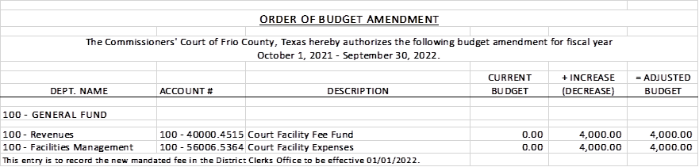

**MOTION: RICHARD GRAF**

**SECOND: RAUL CARRIZALES**

**MOTION PASSED**

6.2 If the amendment is approved, consider/take action on signing order stating same.

(7) Hon. Crystal Marquez, Frio County Auditor, requests:

7.1 Consider / take action to approve the budget amendments to the FISCAL YEAR 2021-2022 Frio County Budget, list below:

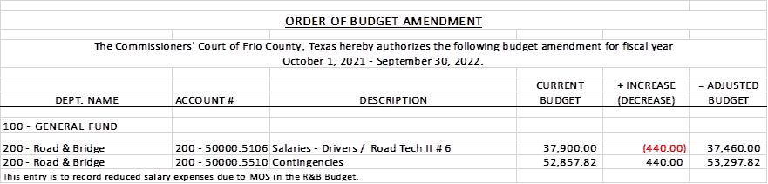

**MOTION: RAUL CARRIZALES**

**SECOND: JOSE ASUNCION**

**MOTION PASSED**

7.2 If the amendment is approved, consider/take action on signing order stating same.

(8) Hon. Crystal Marquez, Frio County Auditor, requests:

8.1 Consider / take action to approve the budget amendments to the FISCAL YEAR 2021-2022 Frio County Budget, list below:

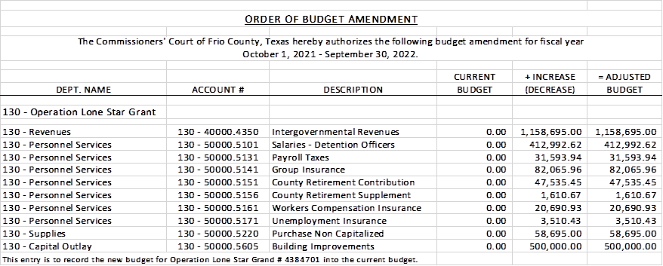

**MOTION: JOSE ASUNCION**

**SECOND: RAUL CARRIZALES**

**MOTION PASSED**

8.2 If the amendment is approved, consider/take action on signing order stating same.

(9) Hon. Crystal Marquez, Frio County Auditor, requests:

9.1 Consider / take action to approve the budget amendments to the FISCAL YEAR 2021-2022 Frio County Budget, list below:

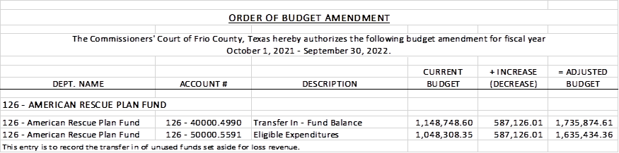

**MOTION: RICHARD GRAF**

**SECOND: JOSE ASUNCION**

**MOTION PASSED**

9.2 If the amendment is approved, consider/take action on signing order stating same.

(10) Hon. Crystal Marquez, Frio County Auditor, requests:

Consider / take action on using ARP eligible expenses to purchase forty-one Pacific Blue Ultra Paper Towel Automatic Dispensers for $1,200.00, and thirty-four boxes of Pacific Blue Ultra Hardwound Paper Towels for $2,300.00 to be utilized by all Frio County Facilities, for a total cost of $3,500.00.

**MOTION: RAUL CARRIZALES**

**SECOND: RICHARD GRAF**

**MOTION PASSED**

(11) Carlos E. Segura, Frio County Elections Administrator, requests:

11.1 Consider/take action on approving Joint Primary Election Services Contract between Frio County and the Frio County Democratic Party for the Frio County Democratic Primary Election on March 1, 2022, and with early voting from February 14, 2022 until February 25, 2022 and any subsequent runoff election.

11.2 If the above contract is approved, consider/take action on signing a resolution authorizing Frio County Judge Arnulfo C. Luna to sign and enter into same on behalf of Frio County, Texas.

11.3 Consider/take action on approving the execution of a Lease Agreement for the use of the Frio County's Electronic Voting Equipment with the Frio County Democratic Party for the Frio County Democratic Primary Election on March 1, 2022, and with early voting from February 14, 2022 until February 25, 2022 and any subsequent runoff election.

11.4 If the above agreement is approved, consider/take action on signing a resolution authorizing Frio County Judge Arnulfo C. Luna to sign and enter into same on behalf of Frio County, Texas.

**MOTION: JOSE ASUNCION**

**SECOND: RICHARD GRAF**

**MOTION PASSED**

(12) Carlos E. Segura, Frio County Elections Administrator, requests:

12.1 Consider/take action on approving Joint Primary Election Services Contract between Frio County and the Frio County Republican Party for the Frio County Republican Primary Election on March 1, 2022, and with early voting from February 14, 2022 until February 25, 2022 and any subsequent runoff election.

12.2 If the above contract is approved, consider/take action on signing a resolution authorizing Frio County Judge Arnulfo C. Luna to sign and enter into same on behalf of Frio County, Texas.

12.3 Consider/take action on approving a Lease Agreement for the use of the Frio County's Electronic Voting Equipment with the Frio County Republican Party for the Frio County Republican Primary Election on March 1, 2022, and with early voting from February 14, 2022 until February 25, 2022 and any subsequent runoff election.

12.4 If the above contract is approved, consider/take action on signing a resolution authorizing Frio County Judge Arnulfo C. Luna to sign and enter into same on behalf of Frio County, Texas.

(13) Hon. Crystal Marquez, Frio County Auditor, requests:

Consider / take action on running a Notice for Public Auction ad (below) in the Frio Nueces Current for one week pursuant to Local Government Code Sec. 263.153.  The ad will run in the Frio-Nueces Current on January 13, 2022.

**MOTION: RAUL CARRIZALES**

**SECOND: RICHARD GRAF**

**MOTION PASSED**

**NOTICE FOR PUBLIC AUCTION**

By order of the Commissioners’ Court of Frio County, Texas, pursuant to Local Government Code 263.152 through 263.157.  Notice is hereby given that an online auction conducted by Rene’ Bates Auctioneers, Inc. will begin on January 24, 2022 and end on February 07, 2022 at 10:00 a.m. The items for auction will be posted on the Rene Bates Auctioneers’ website <http://www.renebates.com>.

All sales shall be finalized on an “as is, where is” basis and no warranties, either expressed or implied, shall be applicable to any property sold. The county reserves the right to withhold any item from sale and the Commissioners’ Court or its designated representative conduction the sale may reject any offer to purchase property if the Court or representative finds the rejection to be in the best interest of the County.

(14) Hon. Crystal Marquez, Frio County Auditor, requests:

Consider / take action on amending the Frio County Purchasing Card and Procedure Policy.

**WILL BE BROUGHT BACK**

(15) Hon. Jose Asuncion, Frio County Commissioner, Precinct No. 4, requests:

15.1 Consider/take action on approving a ARPA Subrecipient Agreement between Frio County and El Sacrificio for use of County-granted ARPA funding.

15.2 If the agreement is approved, then approve and sign a resolution authorizing Frio County Judge Arnulfo C. Luna to execute the contract on behalf of Frio County, Texas.

**$15,000**

**MOTION: JOSE ASUNCION**

**SECOND: RAUL CARRIZALES**

**MOTION PASSED**

(16) Attorney Kirk Swinney, Frio County Appraisal District, requests:

16.1 Discuss and consider approval of an interlocal agreement with Frio County Appraisal District, Pearsall ISD, City of Pearsall, and Frio County Hospital District regarding South Texas Electric Coop., Inc. v. Frio County Appraisal Dist., no. 18-09-00349CVF for post trial costs.

**MOTION: RICHARD GRAF**

**SECOND: RAUL CARRIZALES**

**MOTION PASSED**

16.2 If the agreement is approved, then sign a resolution authorizing Frio County Judge Arnulfo C. Luna to enter into said contract on behalf of Frio County.

(17) Frio County Commissioners Court, requests:

Receive in person from the following county officials the following reports as mandated by law:

17.1 Presentation by Frio County Treasurer of detailed report as mandated by Section 114.026, Local Government (“Code”) (this report is to be presented at each **regular term of commissioners court).**

**MOTION: RICHARD GRAF**

**SECOND: JOSE ASUNCION**

**MOTION PASSED**

17.2 Frio County Treasurer to exhibit the books and accounts of that office for the inspection of the commissioners court (**to be done at each regular term of commissioners court).**

17.3 Consider/take action on authorizing the execution by Frio County Commissioners Court (the Judge and each commissioner) of an affidavit stating the requirements of the treasurer’s report have been met as mandated by section 114.026 of the Code.

17.4 Consider/take action on execution of an order of the commissioners court approving the county treasurer’s report and order their publication in the Frio-Nueces Current as mandated by Section 114.026 of the Code or publication on the county’s website.

(18) Frio County Commissioners Court requests:

Presentation, pursuant to Section 114.044 of the Local Government Code, by:

1. Frio County District Clerk;

2. Frio County Clerk

3. Frio County Treasurer

4. Frio County Attorney

5. Frio County Judge

6. Frio County Sheriff

7. Frio County Auditor

8. Frio County Justice of the Peace

9. Frio County Constables

**(who collects or handles any money for the use of the county) of all fines imposed, judgments rendered and collected, and all jury fees collected by the respected courts in favor of or for the use of the county and at that time when the reports are presented to present receipts vouchers that show disposition of the money, fines or judgments.**

After examination by the commissioners court as to the correctness of the reports, consider/action on directing the county clerk to enter information in county finance records as mandated by Section 114.044 of the Code.

**MOTION: RICHARD GRAF with exception of JP4, Constable 1 & 3**

**SECOND: RAUL CARRIZALES**

**MOTION PASSED**

(19) Documents (resolutions, orders, contracts, etc.) to be signed.

**REVIEWED**

(20) Allow bills payable

**MOTION: RAUL CARRIZALES**

**SECOND: JOSE ASUNCION**

**MOTION PASSED**

(21) Adjourn

**MOTION: RAUL CARRIZALES**

**SECOND: RICHARD GRAF**

**MOTION PASSED**